 |  |  |  | 
 | More | About Me
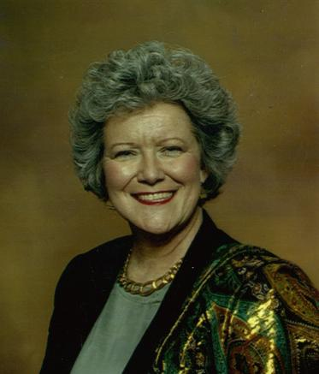
 | Parent of daughter, biomedical engineer, Florida, USA | Why I am a good match for this position  <this would lnk to the sound file> | Selected for Job-Alikes, EARCOS,  Spring 2006 | Emerson Award for Teaching Excellence 2004-2005  <link to site or photos or scanned letter>
home | resume | about me | artifacts | student involvement
 |  |  |  | email to me

