 |  | Elvis Emory Simpson
 |  | My Community Activities
FacultyAdvisor, Student Council,  International School of Cove  <I will would link here to the school student counil page showing my name and photo> |  | Officer, Association for Local Students  <I will link here to the association’s page showing my name and/or photo> |  |  | Volunteer & Leader, Women’s Center  <I will link here to the women’s center>
  home |   resume | 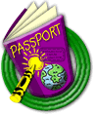  add’l information | 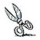  artifacts |   community activities |  | 

