  home    resume    additional information   artifacts | 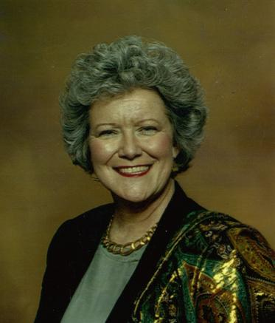
  community  activities | Elvis Emory Simpson  (click below to hear the answer to question)  Why do I want this Internship? | 
AWARDS | EXPERIENCES
Teacher of the Year, World History Association, Region IV | Selected to present paper at the World War II Museum Conference, New Orleans, 2005
Two Former Students Selected as USA Today History Scholars at their Colleges | Worked as History Consultant with Movie Wardrobe Designers,  My Big Fat Old Fashioned Southern Wedding, Spring, 2002

