ELECTRONIC PORTFOLIO 

SAMPLE (Elvis Emory Simpson)

-----------------------------------
PLANNING QUESTIONS

- What font type do you plan to use? I plan to use Comic Sans MS 10 pt

- Are you going to use icons or text for your navigational system? Something else? I am going to use Icons. They are:

 This will represent HOME or the INDEX page.

 This will be my link to my RESUME page, page 2

 This will be my icon link to ADDITIONAL INFORMATION, page 3

 This is my icon link to my ARTIFACTS PAGE, page 4

This is my icon link to my Co-Curricular Page, page 5

 This will be the icon for my email account.

- Describe for me the ‘look’ or ‘feel’ you have planned for your portfolio. I am going to use icons for my navigation that reflect some aspects of The University. I am going to use Crimson, Gray and White as the basic colors. I want my page to look professional yet what it is: a first resume after college. I do not want it to look ‘cutsy’, however.

- What colors or theme are you planning to use on your portfolio? crimson, gray and white

- Describe your general design for the project. For my page, I am going for a page with a definite ‘together’ look. I am going to be using it for an internship application with a specific firm, and I have studied their page, so I know the kind of ‘look’ they have on their corporate page. I want the same ‘tight’ look.
INDEX PAGE (Front Page)

- What title do you plan to use for your portfolio? Electronic Internship Portfolio for Elvis Emory Simpson

- What is the purpose of your portfolio and what should the reader expect to gain from reviewing your portfolio? I am going to use this electronic portfolio as part of my application for an internship with The Edge, an upscale Resort Group. I am hoping to use my marketing and hotel/restaurant management training to get an internship with them on the island of Aruba for the month of January next year.
Here’s a table in WORD showing how my index page (front page) will look:

home
resume | Elvis Emory Simpson’s
Additional Information | Electronic Portfolio
Artifacts |  | The University of Alabama  College of Human and Environmental Sciences
Co-Curricular Activities

PAGE 2 – RESUME – I have saved my resume as .html. Also there will be a link to the WORD version, saved as .pdf.
PAGE 3 – ADDITIONAL INFORMATION

- What precise question did you answer? My Question I have picked was: WHY DO I WANT THIS INTERNSHIP WITH THE EDGE? (see assignment 5.2)

- What do you plan to say in answer to this question? (Write out the answer) I plan to use my .wav file

Make a table showing me how this page (page 3) will look.

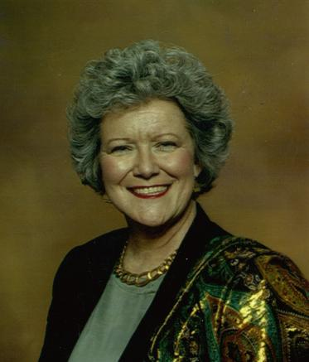

Elvis Emory Simpson
(click on photo to hear the answer to this question:
Why do I want this Internship with The Edge?)

AWARDS | EXPERIENCES
Best Dressed, Hornsby Hall, 2000-2001 | Traveled with Fashion from the Future Group,  Europe & Asia, Summer 2000
Simplicity New Designer of the Southeast, 2001 | Worked with Movie Wardrobe Designers,  My Big Fat Southern Wedding, Spring, 2002

PAGE 4 – ARTIFACTS

- What PRECISE artifacts do you plan to use?

I am going to use the following artifacts:
  - Power Point I made in another one of my classes: CHILDREN’S HEALTH ISSUES 2002
  - A page of photos from Volunteer Activities I did with Special Olympics for HES 310.
  - I am going to upload as a WORD document a research paper I did in Child Development that got published in a parent newsletter. I am going to save the paper I did in WORD as a webpage and upload the .html (webpage) file, but I will also have a click on the page to let the viewer get to the paper as a WORD document, too. My page will look like this:

 | Elvis Emory Simpson
 | ARTIFACTS
 | Power Point Presentation  On Children’s Health Issues
 | Photos from Volunteer Activities with Special Olympics

Research Paper: Child Development
(WORD document)
 | elvissimpson@university.edu

PAGE 5 – COMMUNITY SERVICE or Co-Curricular

- How do you plan to handle the co-curricular (page 5) part of your electronic portfolio?

 | Elvis Emory Simpson
 | My Co-Curricular Activities
Starter, U of Alabama Crew Team  <I will would link here to the team’s page showing my name and photo> | Officer, Association for Local Students  <I will link here to the association’s page showing my name and/or photo> | Official UA Co-Curricular Record  <I will link here to my co-curricular record>
 | elvissimpson@university.edu
I will have my navigational system on here, either along the side or bottom, to match all of the other pages so all pages in my eport have the same layout

Copyrighted 2005
Barrie Jo Price, George E. Marsh II, Anna C. McFadden

